A Comparison of Event Models for Naive Bayes Text Classification

# Andrew McCallum*‡†*

[mccallum@justresearch.com](mailto:mccallum@justresearch.com)

*‡* Just Research 4616 Henry Street

Pittsburgh, PA 15213

# Kamal Nigam*†*

[knigam@cs.cmu.edu](mailto:knigam@cs.cmu.edu)

*†*School of Computer Science Carnegie Mellon University Pittsburgh, PA 15213

**Abstract**

Recent approaches to text classification have used two different first-order probabilistic models for classifica- tion, both of which make the *naive Bayes assumption*. Some use a multi-variate Bernoulli model, that is, a Bayesian Network with no dependencies between words and binary word features (*e.g.* Larkey and Croft 1996; Koller and Sahami 1997). Others use a multinomial model, that is, a uni-gram language model with integer word counts (*e.g.* Lewis and Gale 1994; Mitchell 1997). This paper aims to clarify the confusion by describing the differences and details of these two models, and by empirically comparing their classification performance on five text corpora. We find that the multi-variate Bernoulli performs well with small vocabulary sizes, but that the multinomial performs usually performs even better at larger vocabulary sizes—providing on average a 27% reduction in error over the multi-variate Bernoulli model at any vocabulary size.

# Introduction

Simple Bayesian classifiers have been gaining popularity lately, and have been found to perform surprisingly well

(Friedman 1997; Friedman *et al.* 1997; Sahami 1996; Langley *et al.* 1992). These probabilistic approaches

make strong assumptions about how the data is gen- erated, and posit a probabilistic model that embodies these assumptions; then they use a collection of labeled training examples to estimate the parameters of the generative model. Classification on new examples is performed with Bayes’ rule by selecting the class that is most likely to have generated the example.

The *naive Bayes* classifier is the simplest of these

models, in that it assumes that all attributes of the examples are independent of each other given the con- text of the class. This is the so-called “naive Bayes assumption.” While this assumption is clearly false in most real-world tasks, naive Bayes often performs classification very well. This paradox is explained by the fact that classification estimation is only a function of the sign (in binary cases) of the function estima- tion; the function approximation can still be poor while classification accuracy remains high (Friedman 1997; Domingos and Pazzani 1997). Because of the indepen- dence assumption, the parameters for each attribute can be learned separately, and this greatly simplifies

learning, especially when the number of attributes is large.

Document classification is just such a domain with a large number of attributes. The attributes of the examples to be classified are words, and the number of different words can be quite large indeed. While some simple document classification tasks can be ac- curately performed with vocabulary sizes less than one hundred, many complex tasks on real-world data from the Web, UseNet and newswire articles do best with vo- cabulary sizes in the thousands. Naive Bayes has been successfully applied to document classification in many research efforts (see references below).

Despite its popularity, there has been some confu-

sion in the document classification community about the “naive Bayes” classifier because there are two *dif- ferent* generative models in common use, both of which

make the “naive Bayes assumption.” Both are called “naive Bayes” by their practitioners.

One model specifies that a document is represented by a vector of binary attributes indicating which words occur and do not occur in the document. The number of times a word occurs in a document is not captured. When calculating the probability of a document, one multiplies the probability of all the attribute values, including the probability of non-occurrence for words that do not occur in the document. Here we can un- derstand the document to be the “event,” and the ab-

sence or presence of words to be attributes of the event. This describes a distribution based on a *multi-variate Bernoulli* event model. This approach is more tradi- tional in the field of Bayesian networks, and is appro- priate for tasks that have a fixed number of attributes. The approach has been used for text classification by

numerous people (Robertson and Sparck-Jones 1976; Lewis 1992; Kalt and Croft 1996; Larkey and Croft 1996; Koller and Sahami 1997; Sahami 1996).

The second model specifies that a document is rep- resented by the set of word occurrences from the doc- ument. As above, the order of the words is lost, how- ever, the number of occurrences of each word in the document is captured. When calculating the proba- bility of a document, one multiplies the probability of the words that occur. Here we can understand the in- dividual word occurrences to be the “events” and the document to be the collection of word events. We call

this the *multinomial* event model. This approach is more traditional in statistical language modeling for speech recognition, where it would be called a “uni- gram language model.” This approach has also been used for text classification by numerous people (Lewis and Gale 1994; Kalt and Croft 1996; Joachims 1997; Guthrie and Walker 1994; Li and Yamanishi 1997;

Mitchell 1997; Nigam *et al.* 1998; McCallum *et al.*

1998).

This paper aims to clarify the confusion between these two approaches by explaining both models in detail. We present an extensive empirical compari- son on five corpora, including Web pages, UseNet ar- ticles and Reuters newswire articles. Our results indi- cate that the multi-variate Bernoulli model sometimes performs better than the multinomial at small vocab- ulary sizes. However, the multinomial usually out- performs the multi-variate Bernoulli at large vocabu- lary sizes, and almost always beats the multi-variate Bernoulli when vocabulary size is chosen optimally for both. While sometimes the difference in performance is not great, on average across data sets, the multinomial provides a 27% reduction in error over the multi-variate Bernoulli.

**Probabilistic Framework of Naive Bayes** This section presents the generative model for both cases of the naive Bayes classifier. First we explain the mechanisms they have in common, then, where the event models diverge, the assumptions and formulations of each are presented.

Consider the task of text classification in a Bayesian learning framework. This approach assumes that the text data was generated by a parametric model, and uses training data to calculate Bayes-optimal estimates of the model parameters. Then, equipped with these estimates, it classifies new test documents using Bayes’ rule to turn the generative model around and calculate the posterior probability that a class would have gener- ated the test document in question. Classification then becomes a simple matter of selecting the most probable class.

Both scenarios assume that text documents are gen- erated by a mixture model parameterized by *θ*. The mixture model consists of mixture components *cj*

*∈*

= *c*1*, ..., c* . Each component is parameterized by

*C { }|C|*

a disjoint subset of *θ*. Thus a document, *di*, is created by (1) selecting a component according to the priors, P(*cj θ*), then (2) having the mixture component gener- ate a document according to its own parameters, with distribution P(*di cj*; *θ*). We can characterize the like- lihood of a document with a sum of total probability

*|*

*|*

over all mixture components:

Σ

P(*di|θ*) =

and mixture model components, and thus use *cj* to in- dicate both the *j*th mixture component and the *j*th class.1 In this setting, (supervised learning from la- beled training examples), the typically “hidden” indica-

tor variables for a mixture model are provided as these class labels.

## Multi-variate Bernoulli Model

In the multi-variate Bernoulli event model, a document is a binary vector over the space of words. Given a vocabulary *V* , each dimension of the space *t*, *t*

*∈*

1*,..., V* , corresponds to word *wt* from the vocabu- lary. Dimension *t* of the vector for document *di* is writ- ten *Bit*, and is either 0 or 1, indicating whether word *wt* occurs at least once in the document. With such a document representation, we make the naive Bayes assumption: that the probability of each word occur- ring in a document is independent of the occurrence of other words in a document. Then, the probability of a document given its class from Equation 1 is simply the product of the probability of the attribute values over all word attributes:

*{ | |}*

*|V |*

Y

P(*di|cj*; *θ*) = (*Bit*P(*wt|cj*; *θ*)+ (2)

*t*=1

(1 *− Bit*)(1 *−* P(*wt|cj*; *θ*)))*.*

Thus given a generating component, a document can be seen as a collection of multiple independent Bernoulli experiments, one for each word in the vocabulary, with the probabilities for each of these word events defined by each component, P(*wt cj*; *θ*). This is equivalent to viewing the distribution over documents as being de- scribed by a Bayesian network, where the absence or presence of each word is dependent only on the class of the document.

*|*

Given a set of labeled training documents, = *d*1*,..., d* , learning the parameters of a probabilis- tic classification model corresponds to estimating each

*{ }|D|*

*D*

of these class-conditional word probabilities. The pa- rameters of a mixture component are written *θwt|cj* = P(*wt cj*; *θ*), where 0 *θw c* 1. We can calcu- late Bayes-optimal estimates for these probabilities by straightforward counting of events, supplemented by a prior (Vapnik 1982). We use the Laplacean prior, prim- ing each word’s count with a count of one to avoid prob- abilities of zero or one. Define P(*cj di*) 0*,* 1 as given by the document’s class label. Then, we estimate the probability of word *wt* in class *cj* with:

*| ∈ { }*

*| ≤ ≤|t j*

*θ*ˆ = P(*w |c* ; *θ*) = 1+ Σ*|iD*=*|*1 *Bit*P(*cj |di*) *.* (3)

*i*=1

*j*

*i*

P(*cj|θ*)P(*di|cj*; *θ*)*.* (1)

*|C|*

*wt|cj t j*

2+ Σ*|D|* P(*c |d* )

*j*=1

Each document has a class label. We assume that there is a one-to-one correspondence between classes

1In a more general setting, this one-to-one correspon-

dence can be avoided (Li and Yamanishi 1997; Nigam *et al.*

1998).

The class prior parameters, *θcj* , are set by the maxi- mum likelihood estimate:

Σ ˆ = P(*w |c* ; *θ*ˆ ) = 1+ Σ*|iD*=*|*1 *Nit*P(*cj |di*) *.*

*|D|* P(*c |d* )

*wt|cj*

*t*

*j*

*j*

*|V |* + Σ*|V |* Σ*|D| N*

P(*c |d* )

*θ*

*j*

*θ*ˆ*c*

= P(*cj|θ*ˆ) =

*i*=1 *j*

*|D|*

*i .* (4)

*s*=1

*i*=1 *is*

*j i*

(6)

Note that this model does not capture the number of times each word occurs, and that it explicitly includes the non-occurrence probability of words that do not ap- pear in the document.

## Multinomial Model

In contrast to the multi-variate Bernoulli event model, the multinomial model captures word frequency infor- mation in documents. Consider, for example, the oc- currence of numbers in the Reuters newswire articles; our tokenization maps all strings of digits to a com-

The class prior parameters are calculated as before

according to Equation 4.

## Classification

Given estimates of these parameters calculated from the training documents, classification can be performed on test documents by calculating the posterior probability of each class given the evidence of the test document, and selecting the class with the highest probability. We formulate this by applying Bayes’ rule:

P(*c |θ*ˆ)P(*d |c* ; *θ*ˆ )

mon token. Since every news article is dated, and thus

has a number, the number token in the multi-variate

P(*cj|di*; *θ*ˆ) =

*j i j*

P(*di|θ*ˆ)

*j .* (7)

Bernoulli event model is uninformative. However, news

articles about earnings tend to have a lot of numbers compared to general news articles. Thus, capturing fre- quency information of this token can help classification. In the multinomial model, a document is an ordered sequence of word events, drawn from the same vocab- ulary *V* . We assume that the lengths of documents

are independent of class.2 We again make a similar

naive Bayes assumption: that the probability of each word event in a document is independent of the word’s context and position in the document. Thus, each doc- ument *di* is drawn from a multinomial distribution of words with as many independent trials as the length of *di*. This yields the familiar “bag of words” repre- sentation for documents. Define *Nit* to be the count of the number of times word *wt* occurs in document *di*. Then, the probability of a document given its class from Equation 1 is simply the multinomial distribution:

*|V |* P(*w |c* ; *θ*)*N*

*di|cj*

*|di| |di|*

! *.*

*t*=1

*it*

*θ*

The right hand side may be expanded by first substi- tuting using Equations 1 and 4. Then the expansion of individual terms for this equation are dependent on the event model used. Use Equations 2 and 3 for the multi-variate Bernoulli event model. Use Equations 5 and 6 for the multinomial

## Feature Selection

When reducing the vocabulary size, feature selection is done by selecting words that have highest average mutual information with the class variable (Cover and Thomas 1991). This method works well with text and has been used often (Yang and Pederson 1997; Joachims

1997; Craven *et al.* 1998).

In all previous work of which we are aware, this is done by calculating the average mutual information be- tween the (1) class of a document and (2) the absence

or presence of a word in the document, *i.e.* using a

document event model, the multi-variate Bernoulli. We

*Wt* for a random variable over the absence or presence

write *C* for a random variable over all classes, and write

P( ;

) = P( ) ! Y

*t j it*

*N*

(5)

of word *w*

*t*

in a document, where *Wt*

takes on values

The parameters of the generative component for each class are the probabilities for each word, writ-

*ft* 0*,* 1 , and *ft* = 0 indicates the absence of *wt*,

and *ft* = 1 indicates the presence of *wt*. Average mu-

*∈ { }*

ten *θw |c* = P(*wt|cj*; *θ*), where 0 *≤ θw |c ≤* 1 and

tual information is the difference between the entropy

Σ *t j*

*|*

*t j* of the class variable, *H*(*C*), and the entropy of the class

*t θwt cj* = 1.

Again, we can calculate Bayes-optimal estimates for these parameters from a set of labeled training data. Here, the estimate of the probability of word *wt* in class *cj* is:

2Many previous formalizations of the multinomial model have omitted document length. Including document length

variable conditioned on the absence or presence of the

word, *H*(*C|Wt*) (Cover and Thomas 1991):

*I*(*C*; *Wt*) = *H*(*C*) *− H*(*C|Wt*) (8)

Σ

= *−* P(*c*) log(P(*c*))

*c∈C*

Σ

Σ

is necessary because document length specifies the number of draws from the multinomial. Our the assumption that document length contains no class information is a simpli- fication only. In practice document length may be class de-

pendent, and a more general formalization should capture

this.

+

*ft ∈{*0*,*1*}*

= Σ Σ

*c∈C ft ∈{*0*,*1*}*

P(*ft*) P(*c|ft*) log(P(*c|ft*))

*c*

*∈C*

P(*c, f* ) log . P(*c, ft*) Σ *,*

*t*

P(*c*)P(*ft*)

where P(*c*), P(*ft*) and P(*c, ft*) are calculated by sums over all documents—that is P(*c*) is the number of docu- ments with class label *c* divided by the total number of documents; P(*ft*) is the number of documents contain- ing one or more occurrences of word *wt* divided by the total number of documents; and P(*c, ft*) is the number of documents with class label *c* that also contain word *wt*, divided by the total number of documents.

We experimented with this method, as well as an event model that corresponds to the multinomial: cal- culating the mutual information between (1) the class of the document from which a word occurrence is drawn, and (2) a random variable over all word occurrences. Here the word occurrences are the events. This calcu- lation also uses Equation 8, but calculates the values of the terms by sums over word occurrences instead of over documents—that is P(*c*) is the number of word occurrences appearing in documents with class label *c* divided by the total number of word occurrences; P(*ft*) is the number of occurrences of word *wt* divided by the total number of word occurrences; and P(*c, ft*) is the number of word occurrences of word *wt* that also ap- pear in documents with class label *c*, divided by the total number of word occurrences.

Our preliminary experiments comparing these two feature selection methods on the Newsgroups data set

with the multinomial event model showed little differ- ence in classification accuracy. The results reported in this paper use the feature selection event model that corresponds to the event model used for classification.

# Experimental Results

This section provides empirical evidence that the multi- nomial event model usually performs better than the

multi-variate Bernoulli. The results are based on five different data sets.3

## Data Sets and Protocol

The web pages pointed to by the *Yahoo!* ‘Science’ hi- erarchy were gathered in July 1997. The web pages are divided into 95 disjoint classes containing 13589 pages as the result of coalescing classes of hierarchy-depth greater than two, and removing those classes with fewer than 40 documents. After tokenizing as above and re- moving stopwords and words that occur only once, the

corpus has a vocabulary size of 44383 (McCallum *et al.*

1998).

are on a stoplist, the corpus has a vocabulary of size 29964.

The Newsgroups data set, collected by Ken Lang,

contains about 20,000 articles evenly divided among 20 UseNet discussion groups (Joachims 1997). Many of the categories fall into confusable clusters; for ex- ample, five of them are comp.* discussion groups, and three of them discuss religion. When tokenizing this data, we skip the UseNet headers (thereby discarding the subject line); tokens are formed from contiguous al- phabetic characters with no stemming. The resulting vocabulary, after removing words that occur only once or on a stoplist, has 42191 words.

The WebKB data set (Craven *et al.* 1998) contains

web pages gathered from university computer science departments. The pages are divided into seven cate- gories: student, faculty, staff, course, project, department and other. In this paper, we use the four most populous

entity-representing categories: student, faculty, course

and project, all together containing 4199 pages. We

did not use stemming or a stoplist; we found that us- ing a stoplist actually hurt performance because, for example, “my” is the fourth-ranked word by mutual information, and is an excellent indicator of a student homepage. The resulting vocabulary has 23830 words.

The ‘ModApte’ train/test split of the Reuters 21578

Distribution 1.0 data set consists of 12902 Reuters newswire articles in 135 overlapping topic categories. Following several other studies (Joachims 1998; Liere and Tadepalli 1997) we build binary classifiers for each of the 10 most populous classes. We ignore words on a stoplist, but do not use stemming. The resulting vo- cabulary has 19371 words.

For all data sets except Reuters, naive Bayes is per-

formed with randomly selected train-test splits. The Industry Sector and Newsgroups data sets use five tri- als with 20% of the data held out for testing; Yahoo uses five trials with a 30% test data, and WebKB uses

ten trials with a 30% test data. Results are reported as average classification accuracy across trials. In all experiments with multiple trials graphs show small er- ror bars twice the width of the standard error; however they are often hard to see since they are often quite nar-

row. For Reuters, results on the Mod-Apte test set are

shown as precision-recall breakeven points, a standard information retrieval measure for binary classification. Recall and Precision are defined as:

The Industry Sector hierarchy, made available by *Mar- ket Guide Inc.* (www.marketguide.com) consists of company web pages classified in a hierarchy of industry sectors (McCallum *et al.* 1998). There are 6440 web

Recall = # of correct positive predictions

# of positive examples

Precision = # of correct positive predictions

# of positive predictions

(9)

(10)

pages partitioned into the 71 classes that are two levels deep in the hierarchy. In tokenizing the data we do not stem. After removing tokens that occur only once or

3These data sets are all available on the Inter- net. See <http://www.cs.cmu.edu/>*∼*textlearning and <http://www.research.att.com/>*∼*lewis.

The precision-recall breakeven point is the value at which precision and recall are equal (Joachims 1998).

## Results

Figure 1 shows results on the Yahoo data set. The multinomial event model reaches a maximum of 54%

100

Yahoo Science

100

Newsgroups

80 80

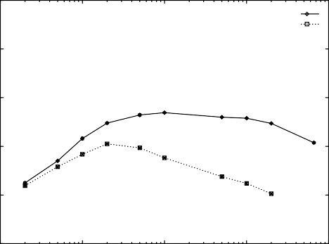

Multinomial Multi-variate Bernoulli

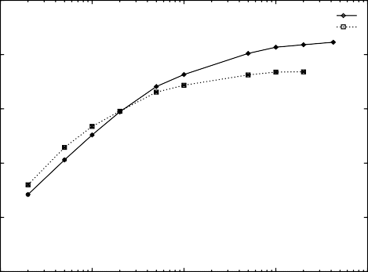

Multinomial Multi-variate Bernoulli

60 60

Classification Accuracy

Classification Accuracy

40 40

20 20

0

10 100 1000 10000 100000

Vocabulary Size

0

10 100 1000 10000 100000

Vocabulary Size

Figure 1: A comparison of event models for different vocabulary sizes on the Yahoo data set. Note that the

multi-variate Bernoulli performs best with a small vo- cabulary and that the multinomial performs best with a larger vocabulary. The multinomial achieves higher

Figure 3: A comparison of event models for different vo- cabulary sizes on the Newsgroups data set. Here, both

data sets perform best at the full vocabulary, but multi- nomial achieves higher accuracy.

accuracy overall.

100

WebKB 4

100

Industry Sector 71

80

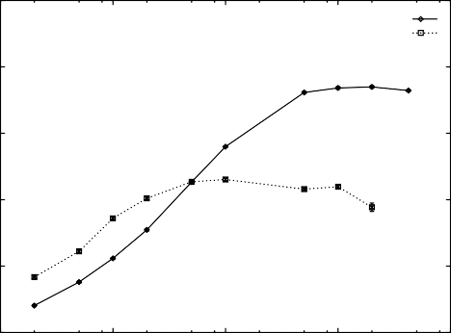

Multinomial Multi-variate Bernoulli

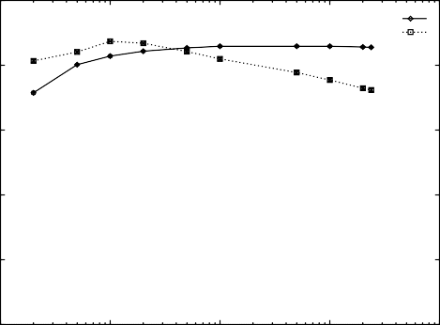

Multinomial Multi-variate Bernoulli

80 60

Classification Accuracy

60 40

Classification Accuracy

40 20

20 0

10 100 1000 10000 100000

Vocabulary Size

0

10 100 1000 10000 100000

Vocabulary Size

Figure 4: A comparison of event models for different vocabulary sizes on the WebKB data set. Here the two

Figure 2: A comparison of event models for different vocabulary sizes on the Industry Sector data set. Note the same trends as seen in the previous figure.

accuracy at a vocabulary size of 1000 words. The multi- variate Bernoulli event model reaches a maximum of 41% accuracy with only 200 words. Note that the multi- variate Bernoulli shows its best results at a smaller vo- cabulary than the multinomial, and that the multino- mial has best performance at a larger vocabulary size.

The same pattern is seen in the Industry Sector data set,

displayed in Figure 2. Here, multinomial has the high- est accuracy of 74% at 20000 words, and multi-variate Bernoulli is best with 46% accuracy at 1000 words.4

Figure 3 shows results for the Newsgroups data set.

Here, both event models do best at the maximum vo- cabulary sizes. Multinomial achieves 85% accuracy and

4Accuracies are higher here than reported in (McCallum *et al.* 1998) because here more training data was provided to this classifier (70% of the data used for training here, versus only 50% in the other work).

event models achieve nearly equivalent accuracies, but the multi-variate Bernoulli achieves this with a smaller vocabulary.

multi-variate Bernoulli achieves 74% accuracy. Previ- ous results in this domain are consistent in that best results were with the full vocabulary (Joachims 1997;

Nigam *et al.* 1998). For the WebKB data, shown in Fig-

ure 4, the multi-variate Bernoulli has marginally higher accuracy than the multinomial, 87% accuracy at 100 words versus 86% accuracy at 5000 words. In ongoing work we are exploring the reasons that this data set shows results different from the others.

Figures 5 and 6 show breakeven point results for the ten Reuters categories. Again, the trends are distinc- tive. The multi-variate Bernoulli achieves a slightly

higher breakeven point in one case, but on average across categories, its best performance is 4.8 percent- age points less than the multinomial. The multi-variate Bernoulli has a rapid decrease in performance as the vocabulary size grows, where the multinomial perfor- mance is more even across vocabulary size. Results by

100

80

Precision/Recall Breakeven Point

60

40

20

interest

curacy. Since our results show that the multi-variate Bernoulli handles large vocabularies poorly, the multi- nomial event model is more appropriate for these chal- lenging classification tasks.

It would be incorrect to argue that multi-variate Bernoulli has the advantage of counting evidence for words that do not occur. Multinomials implicitly en- code this information in the probability distributions

of words for each class. For example, if the word “pro- fessor” is the most likely word for faculty home pages, it will have a large probability for the faculty class, and all

other words will be less probable. If the word “profes-

0

Multinomial Multi-variate Bernoulli

10 100 1000 10000 100000

Vocabulary Size

ship

Multinomial

Multi-variate Bernoulli

100

80

Precision/Recall Breakeven Point

60

40

20

0

10 100 1000 10000 100000

Vocabulary Size

Figure 5: Two of the classification tasks from Reuters. Multinomial event models do an average of 4.8% points better. This domain tends to require smaller vocabular- ies for best performance. See Figure 6 for the remaining

Reuters results.

Joachims (1998) found performance was highest in this domain with the full vocabulary (no feature selection). However, in contrast to our results, this work uses the multi-variate Bernoulli event model for feature selection and the multinomial for classification. In future work we plan to investigate these feature selection methods more closely because we note that our results are con- sistently higher than those found in that work.

## Discussion

For easy classification tasks, a small vocabulary is suffi- cient for high performance. The Reuters categorization

tasks are examples of these—it is well-known that in several of the categories, high accuracy can be obtained with only a handful of words, sometimes even the single word that is the title of the category (Joachims 1998). Our results are consistent with this, in that best per- formance is often achieved with small vocabulary sizes. Many real-world classification tasks do not share this

attribute (*i.e.* that all documents in a category are

about a single narrow subject with limited vocabulary), but instead, a category consists of diverse subject mat- ters with overlapping vocabularies. In such tasks large vocabularies are required for adequate classification ac-

sor” does not then occur in a document, that document will be less likely to be a faculty document, because the words in that document will be lower frequency in the faculty class and higher frequency in others.

Another point to consider is that the multinomial event model should be a more accurate classifier for data sets that have a large variance in document length. The multinomial event model naturally handles docu- ments of varying length by incorporating the evidence of each appearing word. The multi-variate Bernoulli model is a somewhat poor fit for data with varying length, in that it is more likely for a word to occur in a long document regardless of the class. Thus, the vari- ance of the classification should be large for documents of varying lengths. Testing this hypothesis is a topic of future work. Lewis also discusses difficulties with document-length in the multi-variate Bernoulli model. When adding non-text features to the classifier, (such as whether or not an email message has more than one recipient), such features can be included exactly

as the word features are when using the multi-variate Bernoulli model (Sahami *et al.* 1998). However, in the multinomial model more care must be taken. The

non-text features should not be added to the vocabu- lary because then the event spaces for the different fea- tures would compete for the same probability mass even though they are not mutually exclusive. Non-text fea- tures could be added as additional Bernoulli variables to be included in conjunction with the multinomial over words. This approach could also allow for a weighting factor between the word features and the other features. It is also more clear in the multi-variate Bernoulli model how to relax the independence assumption by adding a limited number of dependencies to the

Bayesian network (Sahami 1996; Friedman *et al.* 1997).

# Related Work

Kalt and Croft (1996) previously compared the multi- nomial model to the “binary independence model,” the information retrieval terminology for our multi-variate Bernoulli model. Their theoretical analysis of the multi- nomial does not properly address document length as- sumptions. Their experiments use a single data set with extremely small vocabularies. Also, by normal- izing document length, their event model is no longer strictly a multinomial.

Lewis (1998) discusses the history of naive Bayes in information retrieval, and presents a theoretical comparison of the multinomial and the multi-variate Bernoulli (again called the binary independence model).

# Conclusions

This paper has compared the theory and practice of two different first-order probabilistic classifiers, both of which make the “naive Bayes assumption.” The multi- nomial model is found to be almost uniformly better than the multi-variate Bernoulli model. In empirical results on five real-world corpora we find that the multi- nomial model reduces error by an average of 27%, and sometimes by more than 50%.

In future work we will investigate the role of doc- ument length in classification, looking for correspon- dence between variations in document length and the comparative performance of multi-variate Bernoulli and multinomial. We will also investigate event models that normalize the word occurrence counts in a document by document length, and work with more complex models that model document length explicitly on a per-class basis.

We also plan experiments with varying amounts of training data because we hypothesize that that optimal vocabulary size may change with the size of the training set.

## Acknowledgments

We thank Doug Baker for help formatting the Reuters data set. We thank *Market Guide, Inc.* for permission to use their Industry Sector hierarchy, and Mark Craven for gathering its data from the Web. We thank *Ya- hoo!* for permission to use their data. We thank Tom

Mitchell for helpful and enlightening discussions. This research was supported in part by the Darpa HPKB program under contract F30602-97-1-0215.

# References

Thomas M. Cover and Joy A. Thomas. *Elements of Infor- mation Theory*. John Wiley, 1991.

M. Craven, D. DiPasquo, D. Freitag, A. McCallum,

T. Mitchell, K. Nigam, and S. Slattery. Learning to ex- tract symbolic knowledge from the World Wide Web. In *AAAI-98*, 1998.

P. Domingos and M. Pazzani. On the optimality of the simple Bayesian classifier under zero-one loss. *Machine Learning*, 29:103–130, 1997.

Nir Friedman, Dan Geiger, and Moises Goldszmidt. Bayesian network classifiers. *Machine Learning*, 29:131– 163, 1997.

Jerome H. Friedman. On bias, variance, 0/1 - loss, and the curse-of-dimensionality. *Data Mining and Knowledge Discovery*, 1:55–77, 1997.

Louise Guthrie and Elbert Walker. Document classifica- tion by machine: Theory and practice. In *Proceedings of COLING-94*, 1994.

Thorsten Joachims. A probabilistic analysis of the Rocchio algorithm with TFIDF for text categorization. In *ICML- 97*, 1997.

Thorsten Joachims. Text categorization with Support Vec- tor Machines: Learning with many relevant features. In *ECML-98*, 1998.

T. Kalt and W. B. Croft. A new probabilistic model of text classifica-

tion and retrieval. Technical Report IR-78, University of Massachusetts Center for Intelligent Information Retrieval, 1996. [http://ciir.cs.umass.edu/publications/index.shtml.](http://ciir.cs.umass.edu/publications/index.shtml)

Daphne Koller and Mehran Sahami. Hierarchically clas- sifying documents using very few words. In *Proceedings of the Fourteenth International Conference on Machine Learning*, 1997.

Pat Langley, Wayne Iba, and Kevin Thompson. An anal- ysis of Bayesian classifiers. In *AAAI-92*, 1992.

Leah S. Larkey and W. Bruce Croft. Combining classifiers in text categorization. In *SIGIR-96*, 1996.

D. Lewis and W. Gale. A sequential algorithm for training text classifiers. In *SIGIR-94*, 1994.

David D. Lewis. An evaluation of phrasal and clustered representations on a text categorization task. In *SIGIR- 92*, 1992.

David Lewis. Naive (bayes) at forty: The independence asssumption in information retrieval. In *ECML’98: Tenth European Conference On Machine Learning*, 1998.

Hang Li and Kenji Yamanishi. Document classification using a finite mixture model. In *Proceedings of the 35th Annual Meeting of the Association for Computational Lin- guistics*, 1997.

Ray Liere and Prasad Tadepalli. Active learning with com- mittees for text categorization. In *AAAI-97*, 1997.

Andrew McCallum, Ronald Rosenfeld, Tom Mitchell, and Andrew Ng. Improving text clasification by shrinkage in a hierarchy of classes. In *ICML-98*, 1998.

Tom M. Mitchell. *Machine Learning*. WCB/McGraw-Hill, 1997.

Kamal Nigam, Andrew McCallum, Sebastian Thrun, and Tom Mitchell. Learning to classify text from labeled and unlabeled documents. In *AAAI-98*, 1998.

S. E. Robertson and K. Sparck-Jones. Relevance weight- ing of search terms. *Journal of the American Society for Information Science*, 27:129–146, 1976.

Mehran Sahami, Susan Dumais, David Heckerman, and Eric Horvitz. A bayesian approach to filtering junk e-mail. In *AAAI-98 Workshop on Learning for Text Categoriza- tion*, 1998.

Mehran Sahami. Learning limited dependence Bayesian classifiers. In *KDD-96: Proceedings of the Second Interna- tional Conference on Knowledge Discovery and Data Min- ing*, pages 335–338. AAAI Press, 1996.

V. Vapnik. *Estimations of dependences based on statistical data*. Springer Publisher, 1982.

Yiming Yang and Jan Pederson. Feature selection in sta- tistical learning of text categorization. In *ICML-97*, 1997.

100

acq

100

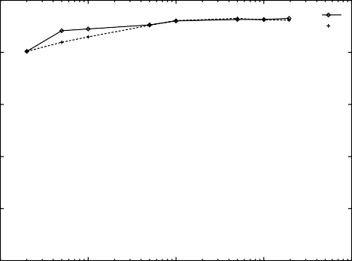

Multinomial

Multi-variate Bernoulli

corn

80 80

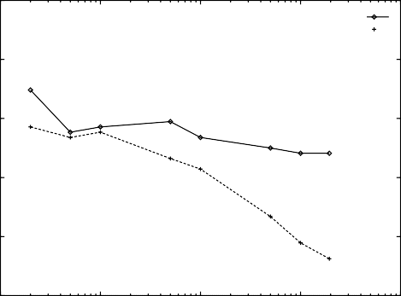

Multinomial

Multi-variate Bernoulli

Precision/Recall Breakeven Point

Precision/Recall Breakeven Point

60 60

40 40

20 20

0

100

10 100 1000 10000 100000

Vocabulary Size

crude

0

100

10 100 1000 10000 100000

Vocabulary Size

earn

80 80

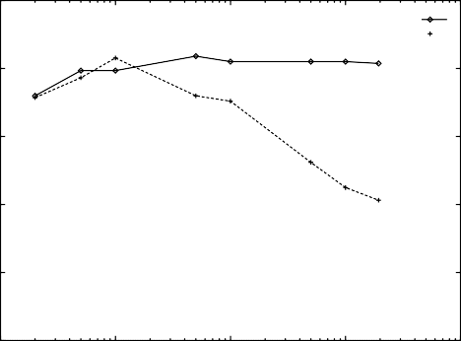

Multinomial

Multi-variate Bernoulli

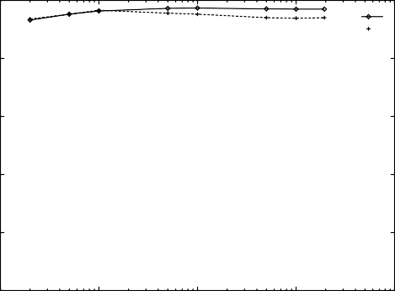

Multinomial

Multi-variate Bernoulli

Precision/Recall Breakeven Point

Precision/Recall Breakeven Point

60 60

40 40

20 20

0

100

10 100 1000 10000 100000

Vocabulary Size

grain

0

100

10 100 1000 10000 100000

Vocabulary Size

money-fx

80 80

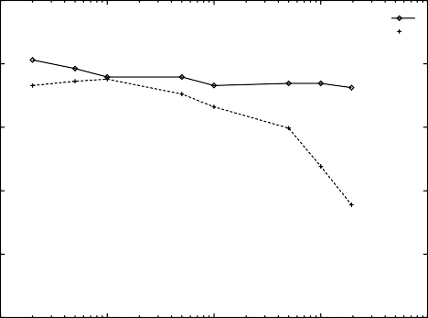

Multinomial

Multi-variate Bernoulli

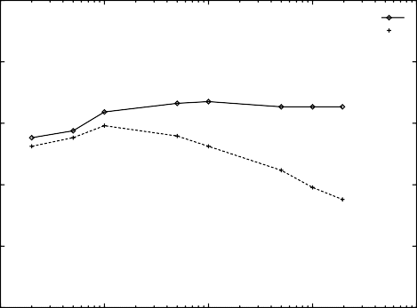

Multinomial

Multi-variate Bernoulli

Precision/Recall Breakeven Point

Precision/Recall Breakeven Point

60 60

40 40

20 20

0

100

10 100 1000 10000 100000

Vocabulary Size

trade

0

100

10 100 1000 10000 100000

Vocabulary Size

wheat

80 80

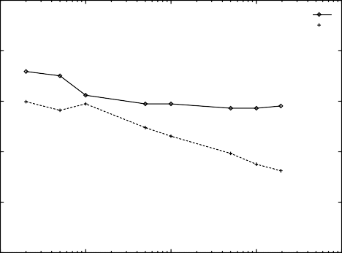

Multinomial

Multi-variate Bernoulli

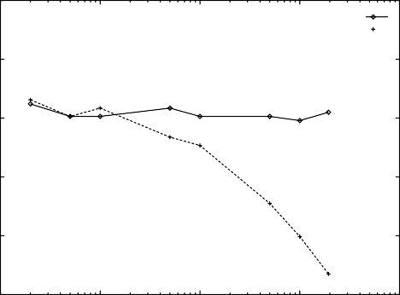

Multinomial

Multi-variate Bernoulli

Precision/Recall Breakeven Point

Precision/Recall Breakeven Point

60 60

40 40

20 20

0

10 100 1000 10000 100000

Vocabulary Size

0

10 100 1000 10000 100000

Vocabulary Size

Figure 6: The continuation of the Reuters results from Figure 5.